Artist Information

Toots Zynsky: 98.222, “Acquamare Chaos”
Mary Ann Zynsky was born in Boston, Mass. And has been known by Toots since she was a child. She received her BFA from Rhode Island School of Design. After receiving her degree, she moved to Seattle, Wash to work at the Pilchuck Glass School under Dale Chihuly. She was named to the American Craft Council College of Fellows in 2008. She was a resident artist at the Corning Museum of Glass in 2016.
Her work is known for featuring the filet-de-verre technique in which fine threads of glass are fused and slumped.

Dale Chihuly: 2007.1593.a,.b, “Great White Shark Gliding on Sea Blue Base”; 2000.904.a-.g, Cadmium Red Seaform with Onyx Wrap”
Chihuly was born in Tacoma, Washington in 1941. After high school he had no intention to further his studies but his mother urged him to attend the College of Puget Sound. A year later he transferred to the University of Washington to study interior design. He learned how to melt and fuse glass in 1961. His many awards include an award from the Louis Comfort Tiffany Foundation and a Fulbright Fellowship. He founded the Pilchuck Glass School with the support of benefactors, John and Anne Gould Hauberg.
While living in England, Chihuly was involved in a head-on car accident which propelled him through the windshield. His face was severely cut and he lost his left eye. In 1979, he dislocated his right shoulder bodysurfing and became unable to blow glass any longer. He continued to develop his own work at Pilchuck and hired others to blow his glass under his direction. In a 2006 interview, Chihuly said “Once I stepped back. I liked the view”, and said it allowed him to see the work from more perspectives, enabling him to anticipate problems earlier. Chihuly’s role has been described as “more choreographer than dancer, more supervisor than participant, more director than actor”.

Thaddaeus Wolfe: 2018.67, “Unique Assemblage Vessel”
Wolfe was born in Toledo, Ohio in 1979 and attended the Cleveland Institute of ART where he received his BFA in 2002.
His work incorporates human-made and organic structures: “I am interested in the organic deterioration of surfaces in my urban surroundings, Czech cubism, visual complexity in simple repeated structures in minerals, plants, and other natural phenomena, and recently poriod patterns in certain bracket-fungi, like the underside of mushrooms.

Linda Macneil: 2002.3926, “Pair of Earrings” and “Necklace” 2002.3927
Macneil was born in 1954 and her later jewelry work is considered wearable sculpture. She individually casts and hand carves or otherwise manipulates each of the glass elements in her neck pieces, ear rings, and brooches. One of the glass making techniques Macneil employs is lost wax casting with pate de verre to create intricate shapes with great surface detail.
Lost wax casting is where an original object is created in wax that is then put in a mold that metal can be poured into. The wax melts from the heat from the liquid metal and is vaporized or lost leaving a metal casting where the wax was inside the mold.

Bohumil Elias: 2002.449, “Inhabitant of Blue”
Elias is a Czech artist born in 1980.
Produced in painted layered glass, Bohumil Eliáš Jr.’s work is most often focused on the architecturally conceived construction of linear structures and rigid forms. In his enclosed forms he creates subtle shimmering compositions.

Michael Glancy: 2007.1549.a-.e “Iterated Symmetry Breaking”
Glancy was born in Detroit, Mich. in1950. He received BFA degrees from the University of Denver and the Rhode Island School of Design. He received his MFA from RISD in 1980 where he studied with Dale Chihuly. He was on the faculty in the Jewelry & Metalsmithing Dept. of RISD and a recurring guest faculty member at the Pilchuck Glass School.
In a book accompanying one of his shows, it was written, “Michael Glancy magnifies nature in order to reveal its underlying structure…the flat glass panels that form sculptural bases for his artworks…unfold into and inspire the vessels that sit astride them.”

Richard Marquis: 2012.603
Marquis was born in 1945 and is one of the first American artists to work in a Venetian glass factory, he became a master of Venetian cane and murine techniques. He is considered a pioneer of American glass art, and is noted for his quirky, playful work that incorporates flawless technique and underlying seriousness about form and color.
Marquis body of work is characterized by a large number of series, often clearly evolving from one to the next. The work is “deceptively irreverent, playful, and frequently witty”, but with amazingly perfected technique and a great deal of attention to form and color, and frequently with reference to classical glass shapes. Found objects, from Marquis’s innumerable collections, are often included in his pieces.

Richard Ritter: 2012.610
Ritter was born in 1940 and lives in North Carolina. He moved to Cass, Mich. in 1978 and was at this time making murrini vessels and paperweights.
A commission from Joan Mondale, wife to then-Vice President Walter Mondale for dessert plates led Ritter to experiment with open platter forms containing murrini and lattacino.
Murrine (singular: murrina) are colored patterns or images made in a glass cane that are revealed when the cane is cut into thin cross-sections. Murrine can be made in infinite designs from simple circular or square patterns to complex detailed designs to even portraits of people. One familiar style is the flower or star shape which, when used together in large numbers from a number of different canes, is called millefiori.
Murrine production first appeared in the Middle East more than 4,000 years ago and was revived by Venetian glassmakers on Murano in the early 16th century.^{[1]}
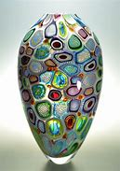
Get pictures of murrini and lattacino
Latticino refers to any glass piece created using colored glass canes. Latticello A decorative glassblowing technique. A latticello is a complicated design where the glass artist uses a latticino to create a reticello like pattern.
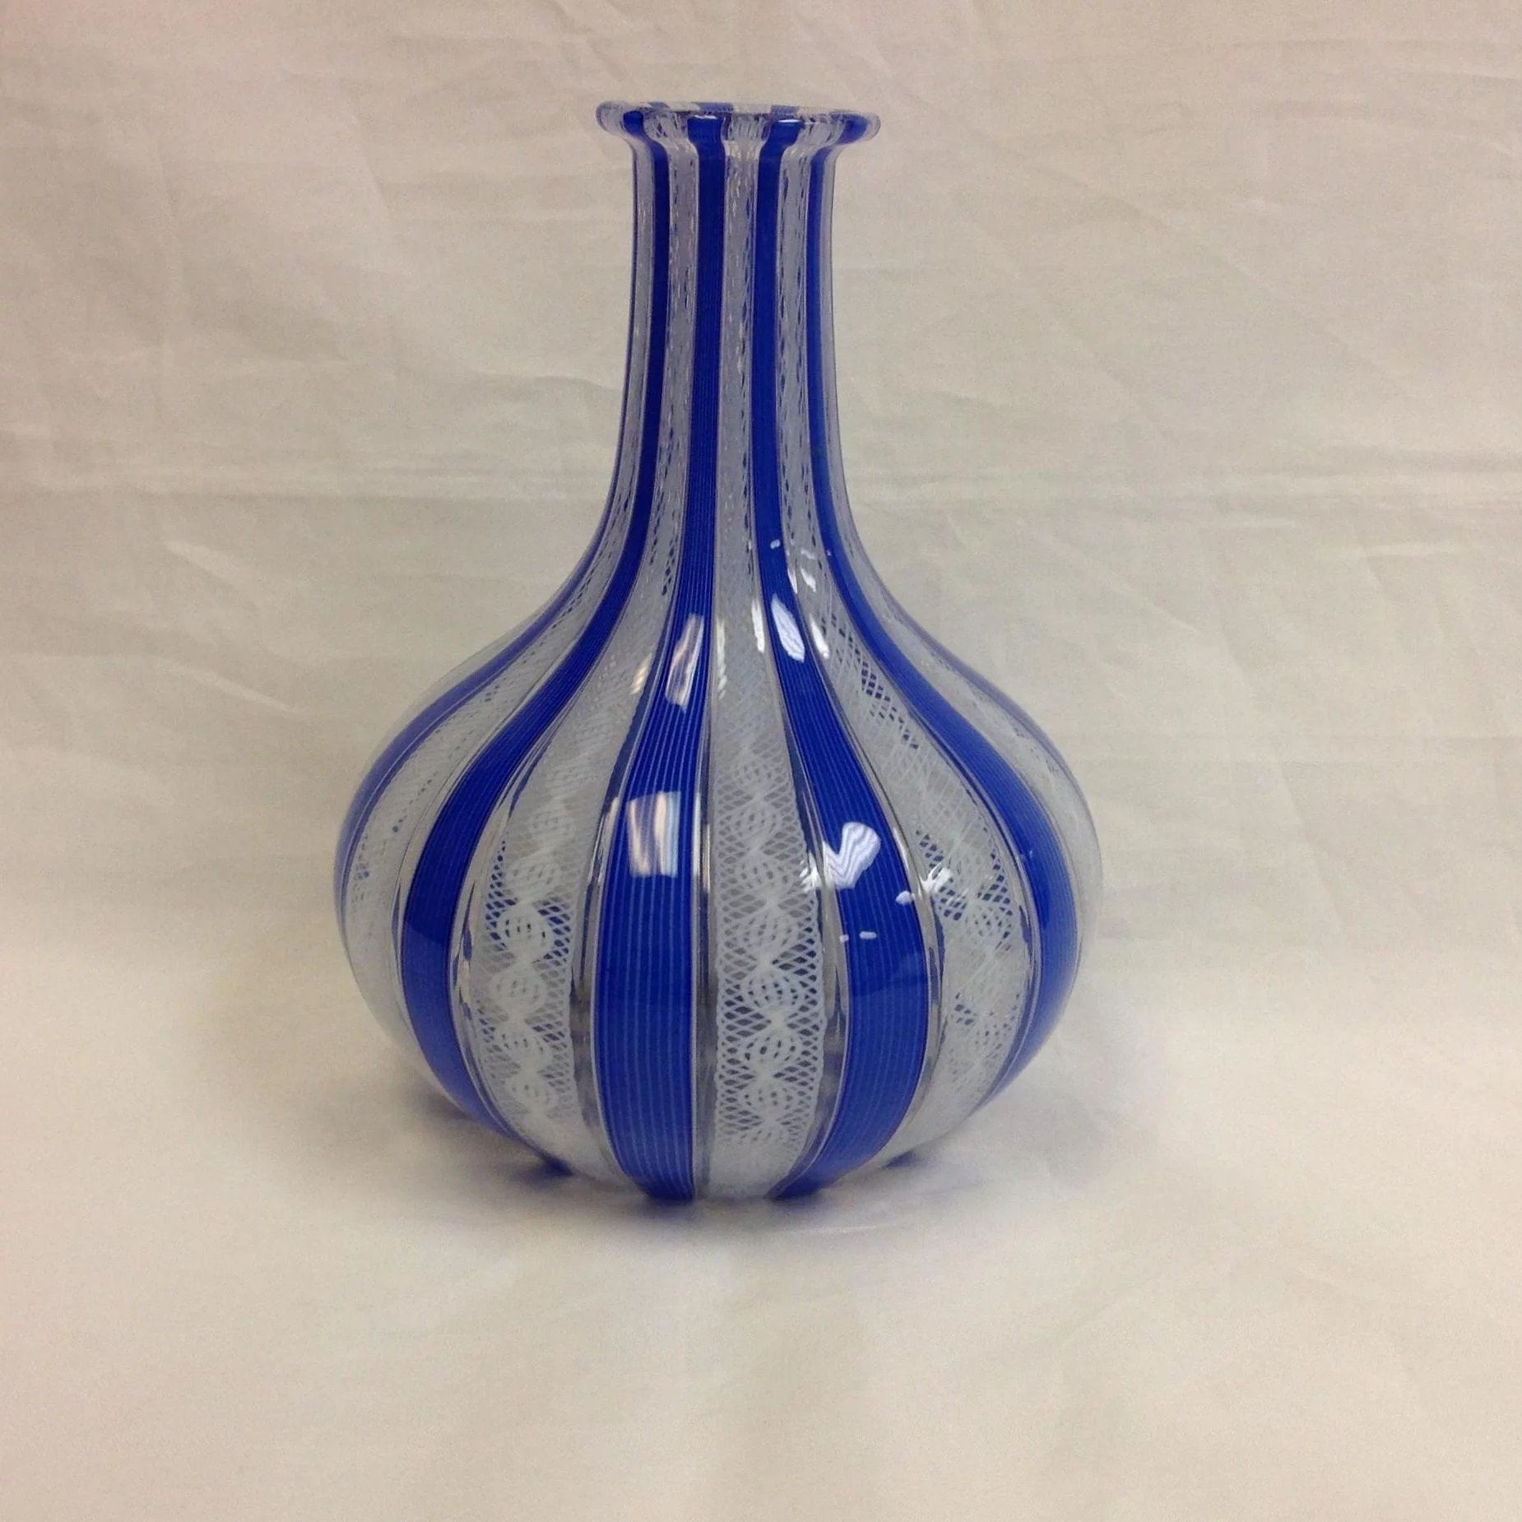

Paul Schwieder: 2007.1542
Schwieder was born in Canada and originally pursued furniture making until, he said, “I fell in love with a red haired girl who was studying glass art and changed my major. Though the relationship was short-lived, his passion for glass was not.
He graduated from Sheridan College of Craft and Design in Ontario and sought employment in foundries throughout the world and instead found himself enrolled in the prestigious Orrefors Glass School in Sweden.
In sculpture, my goal is to create something alluring and magnetic, but also challenging to the viewer.
As a supplement to his own studio work, the award-winning Schwieder maintains a staff of blowers located in Quebec and the Czech Republic who provide him with glass blanks manufactured according to his specifications. The blanks—the “canvasses” upon which Schwieder will be working—are then shipped to Sweden, where he now resides, and prepared to be finished with an exacting sandblasting process. Using a ceramic nozzle that discharges aluminum oxide crystals at an astounding 50-60 psi, Schwieder painstakingly removes glass until his intended design emerges, an approach he likens to using a hammer and chisel on stone. The finished pieces, which can take one hundred hours to complete, are alluringly sophisticated in both their unique forms and complex dimensionality.

Ales Vasicek: 99.268
Vasicek is a Czech Postwar and Contemporary artist who was born in 1947.

Jaroslav Kodejs: 2002.3868; 2005.2136
Jaroslav is a Czech artist born in 1938.
From the mid-60s he began to devote himself to independent jewelry making and in 1971 he had a solo exhibition at the Lobmayer Company in Vienna.
Kodejš's favorite jewelry material was mainly glass and silver. ^{[5]} His first necklaces are composed of clear and pastel-colored glass plates formed over a burner or hollow wound balls connected by metal wires. Later he focused on black glass jewelry. Black costume jewelry is made from preserved original materials and original technology. It consists in soldering glass stones with sealed metal tubes onto a wire pad.

